

**OOP (Object Oriented Programming) Lab**

**LAB REPORT # 2**

**Semester**: 2ndSemester

**Section**: C

**Submitted To:**

**Mr. Muhammad Husnain**

**Submitted By:**

**Name**: Muhammad Afzal

**Roll No**: 22-CS-035

**Task 1:**

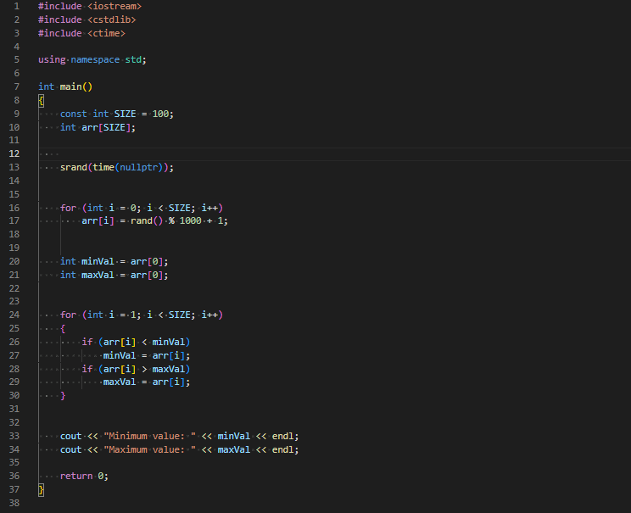

**Output:**



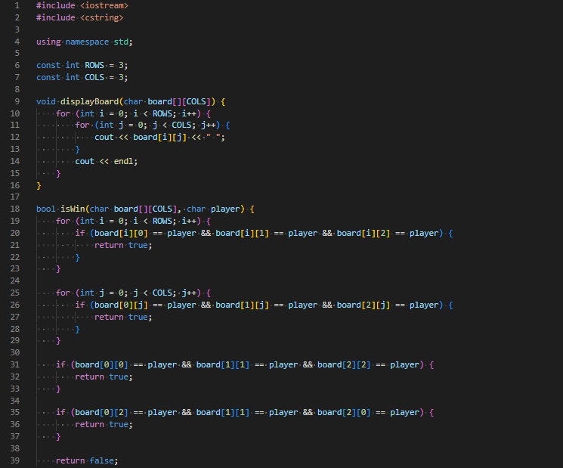**Task 2:**

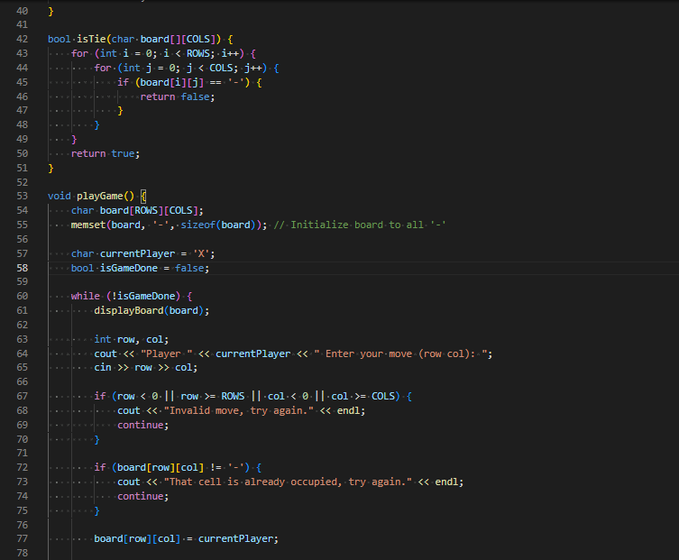

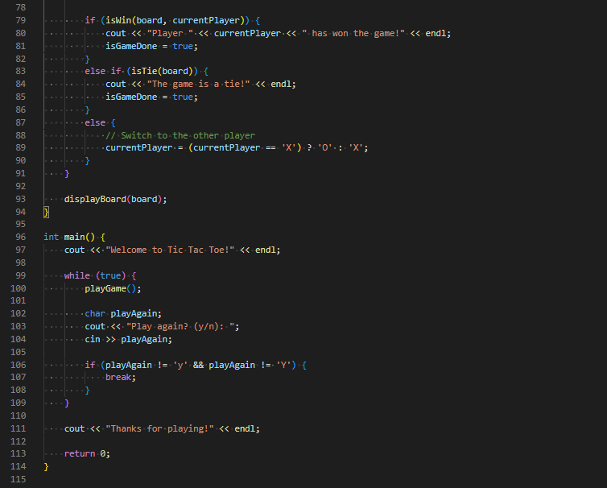

**Output:**



